ESP2 Specifications
This has 1 views: Payment Log
Legend: Bold primary key
Italic foreign key
Bold and Italic primary/foreign key
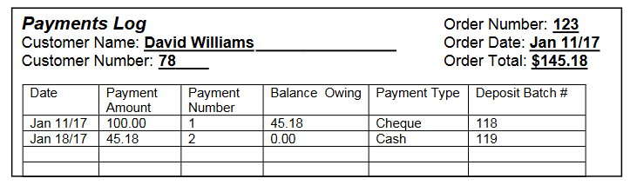
ONF
- Technical Primary Keys
  - When no attribute on your view stands out as a “truly” unique value for the view, one usually creates a new attribute to pose as the primary key
  - This attribute is called a Technical Key
  - This attribute is just numeric value that has NO other purpose then the uniquely identify the row in the table
PaymentLog (PaymentLogID, OrderNumber, OrderDate, OrderTotal, CustomerName, CustomerNumber, (PaymentDate, PaymentAmount, PaymentNumber, BalanceOwning, PaymentType, DepositBatchNumber))
1NF
PaymentLog (PaymentLogID, OrderNumber, OrderDate, OrderTotal, CustomerFirstName, CustomerLastName, CustomerNumber)
PaymentLogDetail(PaymentLogID , PaymentNumber, PaymentDate, PaymentAmount, BalanceOwning, PaymentType, DepositBatchNumber)
2NF
PaymentLog (PaymentLogID, OrderNumber, OrderDate, OrderTotal, CustomerFirstName, CustomerLastName, CustomerNumber)
PaymentLogDetail(PaymentLogID , PaymentNumber, PaymentDate, PaymentAmount, BalanceOwning, PaymentType, DepositBatchNumber)
3NF
- There will be times when a attribute may be consider a removal piece of data into its own table
- To identify, can the same piece of data be commonly found throughout the database and have a uniquely identifiable meaning
- Example: PaymentType
  - Consider moving the attribute into itself own table
  - You will need to create a technical primary key for the new table
  - Why reduce redundancy of the attribute value (in this case the word description)
PaymentLog (PaymentLogID, OrderNumber, CustomerNumber)
PaymentLogDetail (PaymentLogID , PaymentNumber, PaymentDate, PaymentAmount, BalanceOwning, PaymentTypeID, DepositBatchNumber)
Order (OrderNumber, OrderDate, OrderTotal)
Customer (CustomerNumber, CustomerFirstName, CustomerLastName)
PaymentType (PaymentTypeID, PaymentTypeDescription)

Merging ESP 2 with ESP 1
Customer (CustomerNumber, FirstName, LastName, Address, City, Province, PostalCode, HomePhone)
Order (OrderNumber, CustomerNumber, OrderDate, Subtotal, GST, Total)
OrderItems (OrderNumber, ItemNumber, Quantity, OrderPrice, Amount)
Item (ItemNumber, Description, CurrentPrice)
PaymentLog (PaymentLogID, OrderNumber, CustomerNumber)
PaymentLogDetail (PaymentLogID , PaymentNumber, PaymentDate, PaymentAmount, BalanceOwning, PaymentTypeID, DepositBatchNumber)
PaymentType (PaymentTypeID, PaymentTypeDescription)

